So in this lesson we will start making game over menu for our game

Now inside canvas we create another panel.

This panel will hold all the ting in our game over menu

We will disable it tapText and previous panel as we don’t need it now

Now we rename our new panel as GameOverPanel

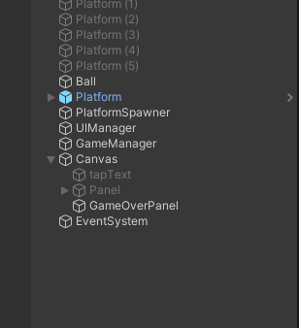

Now this is the thing that will hold game over things together

1:10

We rename it to GameOverPanelHolder

Now inside this we will place another panel and name it ScorePanel

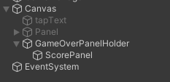

And then we will position it and GameOverPanelHolder as shown below

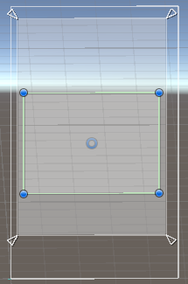

We will increased the alpha of ScorePanel so it will be brighter

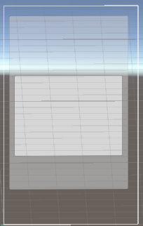

Now we will make the alpha of GaveOverPanel Holder 0 so it will not be visible

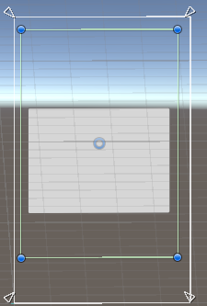

Now inside this scorePanel we add a text

And make the font size 40 so it will be bigger and reset its position so It will come in the center by default

And make the text as score :

Now align the text in the center horizontally

Now it will look like below

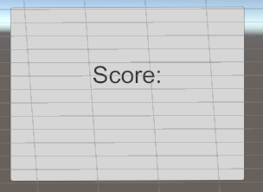

Now we will duplicate the text and drag it below the score: and then set its text to 0 now it will look like below:-

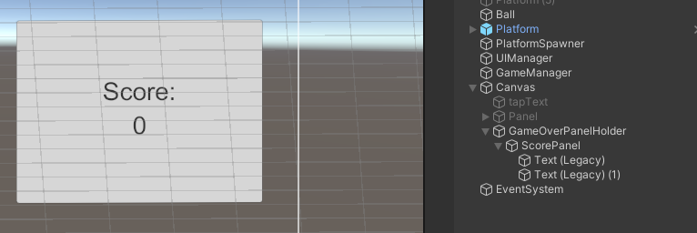

We now we will rename the duplicated text and rename it as score as shown below

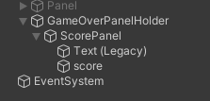

Now we will again duplicate the text again and drag it below the 0 and then set its text to Best score:

as shown below

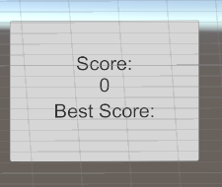

Now this time we will duplicate the score text and drag it below the Best Score as shoen below

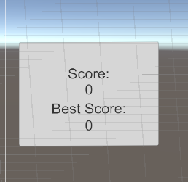

Now we will rename the duplicate score to highScore as shown below

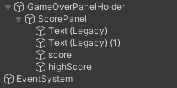

Now we add another text but this time inside GameOverPanelProperties

And now we set its text to GAME OVER

And now place this text above the GameOverHolderPanel

And now horizontal center align it

Now we increase its font Size to 60

Now it will look like below

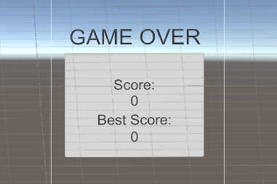

Make the font style to Bold

SO this is our GameOver Text

Now you see its pretty dull in game Panel

6:35

Now you can see it is looking like dull

We need to change its background

By selecting the main camera

And then go to Inspector panel and then in camera subpanel

Choose solid color in place of skybox so that camera will show only color as a specific background Now in background choose the color you want for the background of whatever the camera can see



In background field we choose light green color

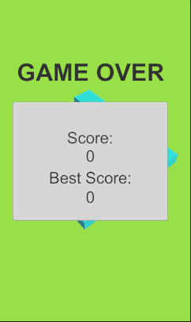

Now it will look like above

Now what we need to create an animation for our gameOverPenalHolder

By selecting our gameOverPanel Holder we go to animation tab and then create animation there

And name it gameOverPanelAppear

Now click on record button and then in first frame move the panel out of the screen towards the right direction   
Now go to 60 frames and then move it back inside and then place it in the center

Now go to animator tab and then

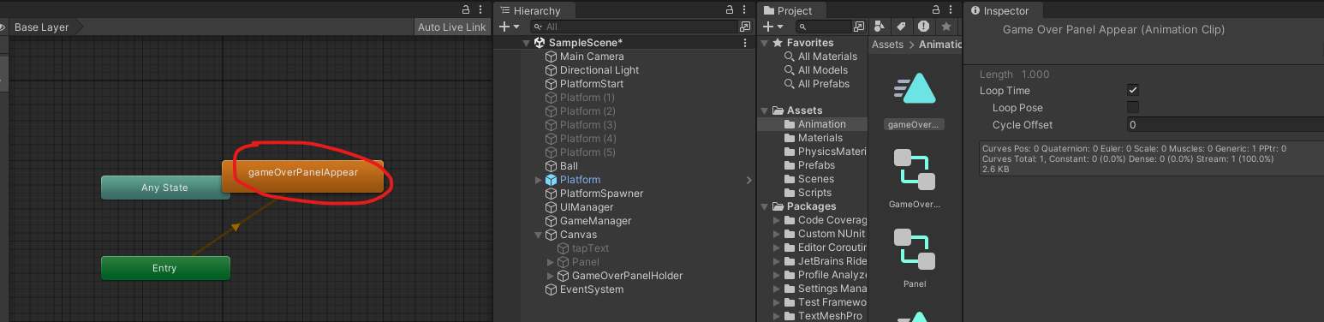

Now double click on the box representing the animation we made and then we go to event loop and uncheck it

Now our game over animation will be played only once

So in beginning what we need to do is disable this Game over Panel holder and whenever we enable it the animation will be played automatically (It will happen in the runtime of the game)

Now we enable the panel

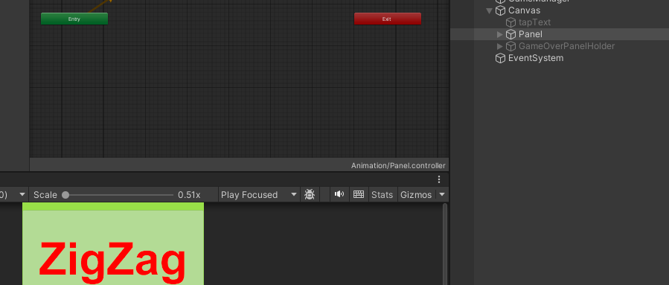 we created   
Now in animator we can see the panelUp is the default animation linked with our panel IOT

We rename the panel IOT to ZigZagPanel

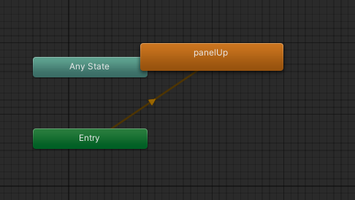

When we play our game then it start moving automatically up but we don’t need to do that

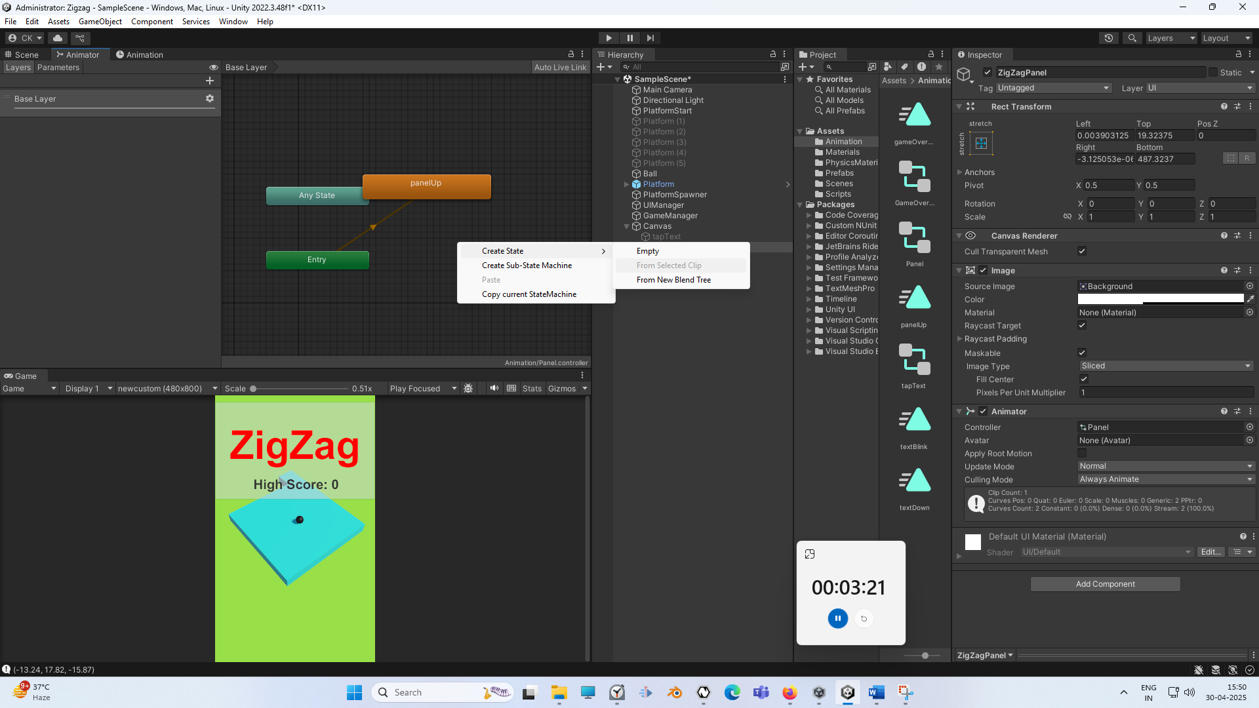

So for that We create an empty state by right clicking on the Animator panel and then go to clean State and then to Empty Now an empty state will be created

Now make it your default state like you made it previously now it will look like below

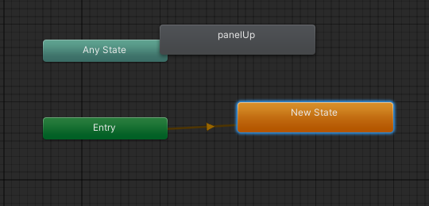

10:25

By this way we can set to a state where nothing happens

But when we go to panelUp state then the zigzag symbol go up

In next lesson we will create out UI Manager

And write code in it so that we can control all these different animation

Then we will create our scores and then we are gonna control all of them by using our game manager

So see you in the next lesson